**PROJECT PROPOSAL**

**Course:** Software Design and Analysis

**Instructor:** Miss Lehmia Kiran

**Section:** 5C

**Project Name:** Speedify - (Courier Management System CMS)

**Project Members:** Hashim Khan, Tayyab Irfan, Hannan Fareed.

**SPEEDIFY:**

Speedify is actually a Courier Management System (CMS) that is designed to streamline, manage, automate and optimize various aspects of courier and parcel delivery services. Speedify will help courier companies and logistics providers to manage their operations more efficiently and effectively.

**Objective:**

Our objective to build Courier Management System is to help courier companies enhance their service quality, reduce operational costs, user-friendly services, scalability and improve customer satisfaction.

**Modules:**

Our Speedify CMS will be based on three modules:

* 1- User Management Module
* 2- Parcel Management Module
* 3- Admin and Reporting Module:

**Module 1 - Admin Management Module:**

The management of user accounts and the system-related actions they do are the main topics of this module.

It includes features such as:

* **Customer Management:** Registration, login, profile management, and account preferences for customers.
* **Courier Staff Management:** Registration, login, and profile management for courier personnel.
* **Admin Management:** User roles and permissions for administrators who oversee the system.
* **Authentication and Authorization:** Securely handle user authentication and authorization to access various system features.

**Module 2 - Parcel Management:**

The primary functions of managing packages, shipments, and deliveries are covered in this module.

It includes features such as:

* **Parcel Booking:** Allow customers to create and schedule parcel deliveries, specifying sender and recipient details, parcel contents, and delivery preferences.
* **Parcel Tracking:** Implement real-time parcel tracking to provide customers with updates on their shipment's status.
* **Perishable Products:** Product distinction, Expiry date tracking,
* **Delivery Scheduling:** Enable customers to set delivery dates and times according to their preferences.
* **Parcel Sorting:** Automated sorting of parcels based on destination. Sorting by weight, or delivery address.
* **Payment Processing:** Handle payments for courier services, generate invoices, and manage billing.
* **Inventory Management:** Keep track of available courier resources, including vehicles, personnel, and packaging materials such as:
* **Parcel Storage:** Keep track of parcels stored in the warehouse or sorting centre. Each parcel should be associated with a unique identifier or barcode for easy retrieval.
* **Stock Levels:** Monitor the quantity of parcels in stock for different destinations, sizes, or types. Get real-time updates on stock levels to ensure you have enough parcels on hand to meet demand.
* **Returns Management:** Handle product returns efficiently, including tracking return requests, processing returns, and managing returns-related documentation.

**Module 3 – Reporting and Customer Support:**

This module focuses on managing the system's operations and producing reports and is primarily intended for system administrators.

It includes features such as:

* **Admin Dashboard:** Provide an administrative dashboard with user management tools, analytics, and system settings.
* **Courier Assignment:** Assign courier personnel to parcels, manage delivery routes, and ensure timely deliveries.
* **Reporting and Analytics:** Generate reports and analytics on various aspects of the courier service, including delivery performance, revenue, and customer feedback.
* **Notifications Management:** Admins can send notifications to users, manage and configure automated alerts.
* **Feedback and Ratings:** Allow customers to provide feedback and ratings on their delivery experience, Quality assurance.

**CLASS ANALYSIS DIAGRAM**

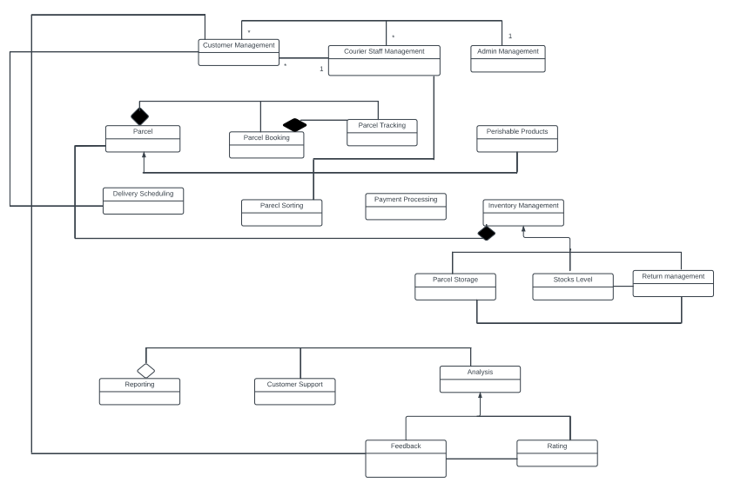

**USE CASE DIAGRAM**

